**[FREE GUIDE] Install ComfyUI, Tooncrafter & use my workflows for “Make your own ANIME with this new mind-blowing AI TOOL”**

This is the free guide for my video “Create consistent, poseable AI characters and backgrounds for your projects! (ComfyUI Tutorial)”.

I tested all my workflows on an RTX 2070 GPU with 8 GB of VRAM. Better ones recommended, but it works pretty well with 8GB VRAM.

If you’re having trouble feel free to post your issue in the **#need-help** channel on my discord that you can access if you support me on Patreon. I’ll try to help everyone out there!

**1 Install ComfyUI**

1. Download ComfyUI: <https://github.com/comfyanonymous/ComfyUI>
2. Extract the folder to the location where you want to install ComfyUI.
3. Download ComfyUI Manager: <https://github.com/ltdrdata/ComfyUI-Manager>
4. Extract it, put it into your ComfyUI directory and run it.
5. After it’s done you can run ComfyUI by clicking **run_nvidia_gpu**

Congratulations, you installed ComfyUI! 🥳 To use my workflow you’ll need some extra models and extensions, but it is super easy to install them!

**2 Install Tooncrafter**

1. For Tooncrafter to work faster, you should install **Xformers**. Open your ComfyUI portable folder. Right click inside of it and choose “open in terminal”.
2. Paste in python_embeded\python.exe -m pip install xformers --no-deps and hit enter. Wait until it's done. You can find more information on installing Tooncrafter [here](https://github.com/kijai/ComfyUI-DynamiCrafterWrapper).
3. Start ComfyUI and open the ComfyUI Manager. Click “Install custom nodes” and search for Tooncrafter.
4. Install ComfyUI-DynamiCrafterWrapper as shown below.
5. When you first run Tooncrafter it will download all the models. This takes some time!

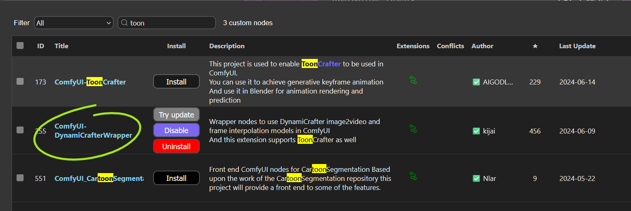

**3 Download the Models**

Download these models and put them in the corresponding folders:

1. **Checkpoint:** <https://civitai.com/models/293331/wildcardx-xl-turbo> **< recommended model!**

📁 ComfyUI_windows_portable\ComfyUI\models\**checkpoints**

| **!** | You can also use any other SDXL or SD 1.5 checkpoints. I recommend LCM, Turbo or lightning ones though for faster generation time especially for the video workflows. You can find more models on CivitAI.com. Check the example images for the settings and match them in your KSamplers! |
| --- | --- |

1. **SDXL CONTROLNET:** <https://huggingface.co/lllyasviel/sd_control_collection/tree/main>

(sai_xl_depth_256lora )

and: <https://huggingface.co/thibaud/controlnet-openpose-sdxl-1.0/tree/main>

(OpenPoseXL2.safetensors)

📁 ComfyUI_windows_portable\ComfyUI\models\controlnet\**sdxl**

1. **SD 1.5 CONTROLNET** https://huggingface.co/lllyasviel/ControlNet/tree/main/models

([control_sd15_canny.pth](https://huggingface.co/lllyasviel/ControlNet/blob/main/models/control_sd15_canny.pth))

📁 ComfyUI_windows_portable\ComfyUI\models\controlnet\

1. **ANIMATEDIFF MODEL:** <https://huggingface.co/hotshotco/Hotshot-XL/tree/main>

(hsxl_temporal_layers.safetensors)

📁ComfyUI_windows_portable\ComfyUI\custom_nodes\ComfyUI-AnimateDiff-Evolved\**models**

1. **IP ADAPTER MODELS:** <https://huggingface.co/h94/IP-Adapter/tree/main/sdxl_models>

(all of them)

📁 ComfyUI_windows_portable\ComfyUI\custom_nodes\ComfyUI_IPAdapter_plus\**models**

1. **CLIP VISION:**

[**CLIP-ViT-H-14-laion2B-s32B-b79K.safetensors**](https://huggingface.co/h94/IP-Adapter/resolve/main/models/image_encoder/model.safetensors)**, download and rename**

[**CLIP-ViT-bigG-14-laion2B-39B-b160k.safetensors**](https://huggingface.co/h94/IP-Adapter/resolve/main/sdxl_models/image_encoder/model.safetensors)**, download and rename**

📁 ComfyUI_windows_portable\ComfyUI\models\**clip_vision**

1. **Install ComfyUI Essentials** Open the ComfyUI Manager > Install Custom Nodes > Search Essential > Install & Restart

| **!** | If you're having trouble with installing the ipAdapter nodes and models, try to install them via the ComfyUI manager! |
| --- | --- |

**4 Optional: SD15 LCM WORKFLOW - Download the Models:**

Download these models and put them in the corresponding folders:

1. **Checkpoint:** <https://civitai.com/models/46422/juggernaut>

📁 ComfyUI_windows_portable\ComfyUI\models\**checkpoints**

| **!** | You can also use any other SD 1.5 checkpoints with baked VAE. I just used Juggernaut Reborn for testing a lot and it worked great. |
| --- | --- |

1. **CONTROLNET MODELS:** <https://huggingface.co/lllyasviel/ControlNet/tree/main/models>

( [control_sd15_depth.pth](https://huggingface.co/lllyasviel/ControlNet/blob/main/models/control_sd15_depth.pth), [control_sd15_normal.pth](https://huggingface.co/lllyasviel/ControlNet/blob/main/models/control_sd15_normal.pth), [control_sd15_canny.pth](https://huggingface.co/lllyasviel/ControlNet/blob/main/models/control_sd15_canny.pth) )

📁 ComfyUI_windows_portable\ComfyUI\models\controlnet\

1. **ANIMATEDIFF MODEL:** <https://huggingface.co/wangfuyun/AnimateLCM>

([AnimateLCM_sd15_t2v.ckpt](https://huggingface.co/wangfuyun/AnimateLCM/blob/main/AnimateLCM_sd15_t2v.ckpt))

📁ComfyUI_windows_portable\ComfyUI\custom_nodes\ComfyUI-AnimateDiff-Evolved\**models**

1. **ANIMATEDIFF LCM LORA:** <https://huggingface.co/wangfuyun/AnimateLCM/tree/main>

([AnimateLCM_sd15_t2v_lora.safetensors](https://huggingface.co/wangfuyun/AnimateLCM/blob/main/AnimateLCM_sd15_t2v_lora.safetensors))

📁 ComfyUI_windows_portable\ComfyUI\models\**loras**

1. **IP ADAPTER MODELS:** <https://huggingface.co/h94/IP-Adapter/tree/main/models>

(All of them. You can also install them via the ComfyUI manager > Install models)

📁 ComfyUI_windows_portable\ComfyUI\custom_nodes\ComfyUI_IPAdapter_plus\**models**

1. **CLIP VISION:**

[**CLIP-ViT-H-14-laion2B-s32B-b79K.safetensors**](https://huggingface.co/h94/IP-Adapter/resolve/main/models/image_encoder/model.safetensors)**, download and rename**

[**CLIP-ViT-bigG-14-laion2B-39B-b160k.safetensors**](https://huggingface.co/h94/IP-Adapter/resolve/main/sdxl_models/image_encoder/model.safetensors)**, download and rename**

📁 ComfyUI_windows_portable\ComfyUI\models\**clip_vision**

1. **Upscale model:**

Go into the comfyUI manager, “Install models”, search for upscale and choose 4xUltrasharp. You can also try any other upscale models. Make sure that you select the correct one in the “Load upscale model” node in your ANIME FIX workflow.

**5 Install the workflow (Custom Nodes)**

1. Now select a workflow and drag & drop it into your ComfyUI interface.
2. A lot of the nodes will be red, because they are not installed yet. To install them, go to ComfyUI Manager -> Install missing Custom Nodes.

| **!** | If you're having trouble with some of the custom nodes not installing properly, go to “install missing custom nodes” in the ComfyUI manager, delete them and go to “install custom nodes”, search for them and install them from there. |
| --- | --- |

1. When it’s done, restart ComfyUI.

| **!** | Double check all “load” nodes! (Load Checkpoint, Load Controlnet Model) and check if all the models are loaded correctly. You might need to re-select them to work.  Also, when first using the workflows it might download some extra models (for example for the RemBG node. It will only need to do that once though so after that it will be a lot faster. |
| --- | --- |

1. Have fun generating!